How to Assemble Bont Ultrasprint Blades

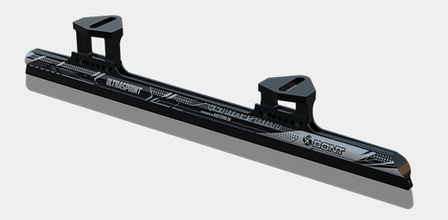

- It is important to note that the writing on the blades faces OUT on both sides.
- The front of the blades is indicated with an “F” on each blade.
- Cups on both blades point to the right.
- Tall Cup at the back, short cup in front
- Cups can be moved in or out to allow for 5.5” spacing on smaller boots and 6.5” spacing on larger boots.
- Please be sure to sharpen and polish the blades well after they have been rockered.

Happy Skating!

